Accessibility and Inclusion Plan
Plan Tracker
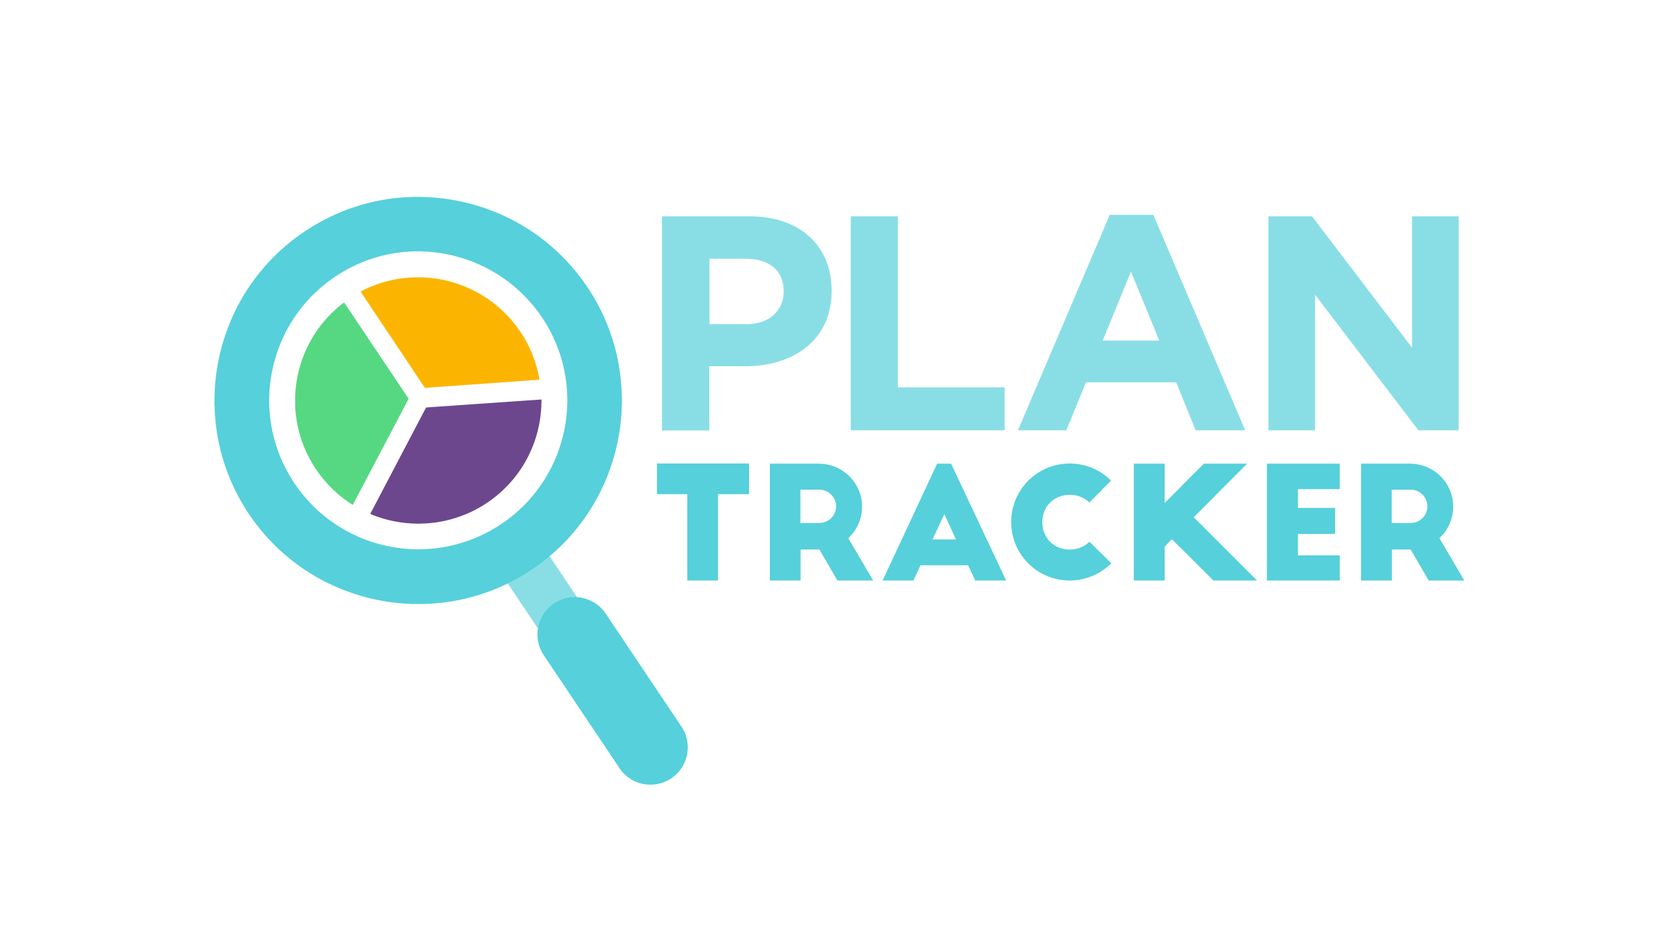
July 2022 – June 2024
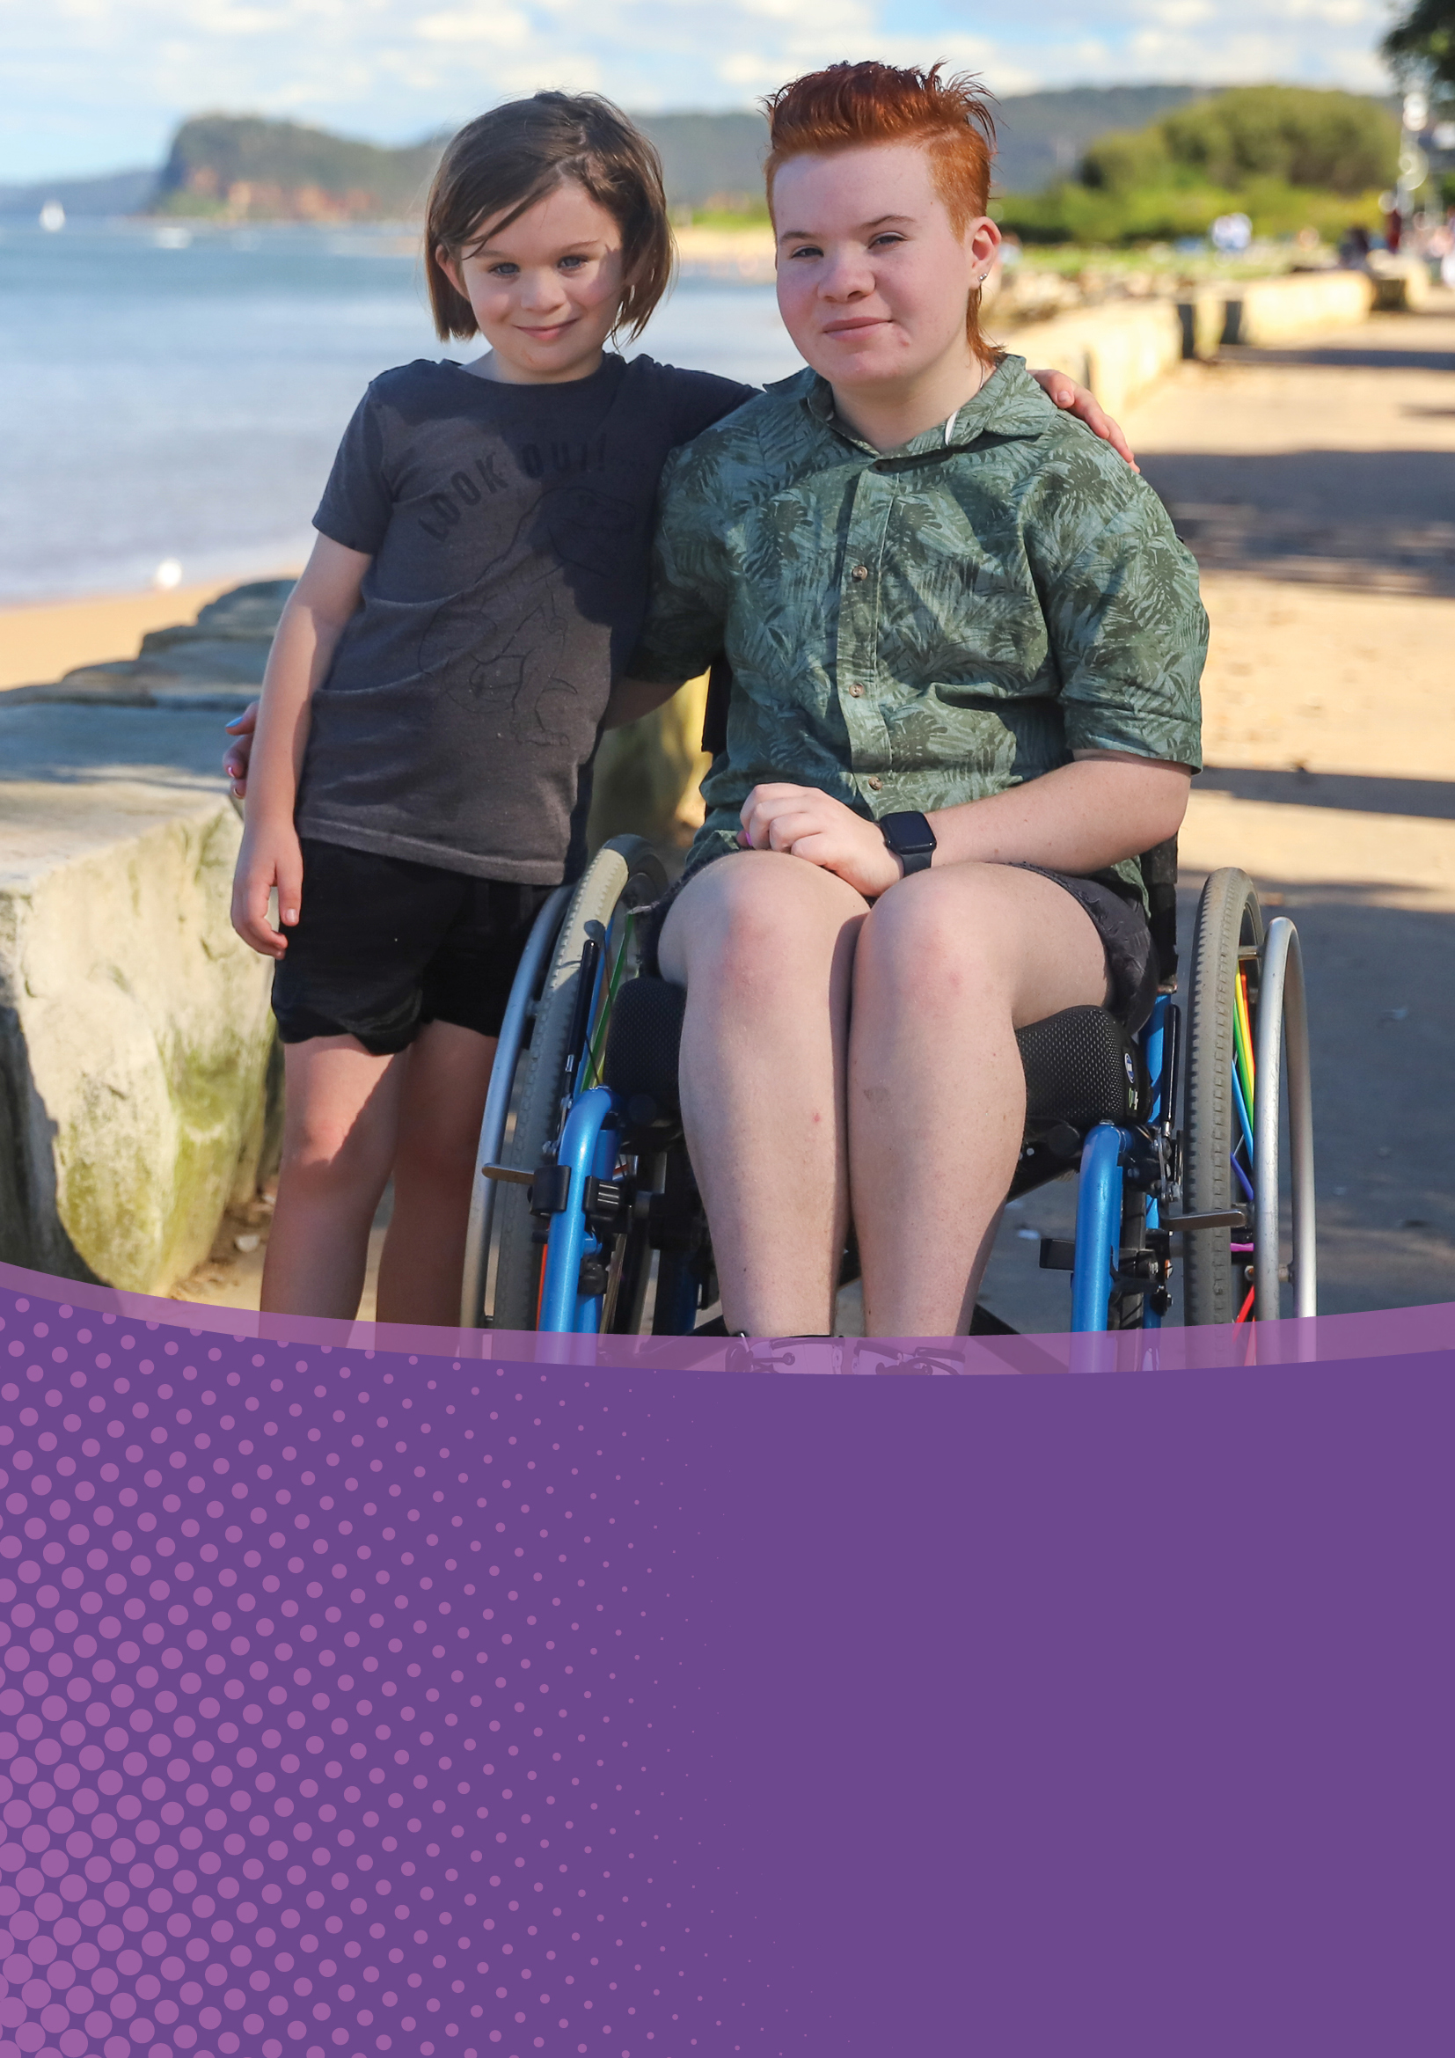

MMS acknowledges and celebrates the contributions made by people with disability to our organisation and society, and the critical importance of providing equitable access to opportunities for people living with disability and carers of people with disability to achieve their goals in life.
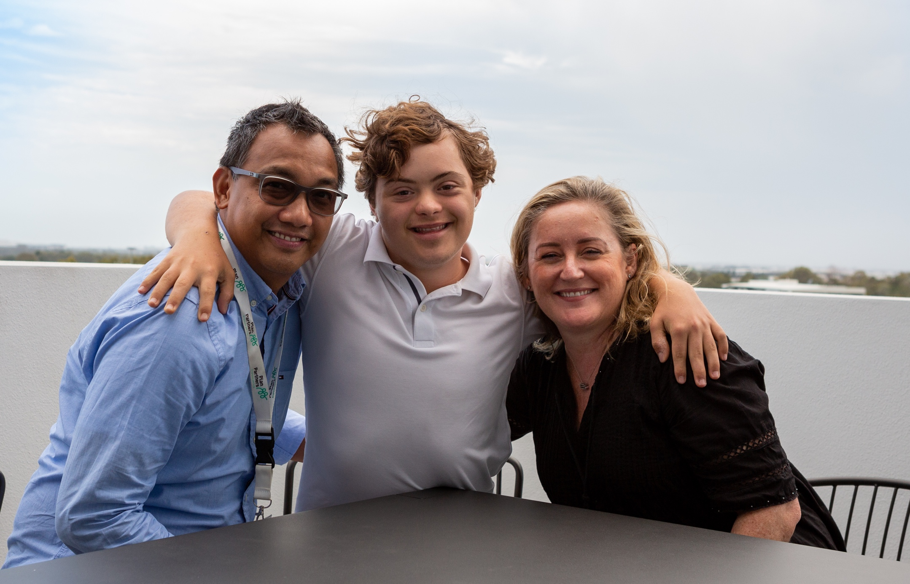

Table of Contents
Introduction: 3
Understanding Disability: 5
Our Business: 9
Our Accessibility and Inclusion Plan: 13
Our Commitments: 17

Acknowledgement of Country
MMS acknowledges the Aboriginal and Torres Strait Islander Peoples as the Traditional Owners and Custodians of the land. We recognise their connection to land, water, and community, and pay our respects to Elders past, present and emerging. We extend our respect to Aboriginal and Torres Strait Islander Peoples living today.

United Nations Sustainable Development Goals
Through this Accessibility and Inclusion Plan, MMS supports the achievement of the following United Nations Sustainable Development Goals:
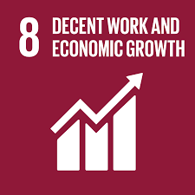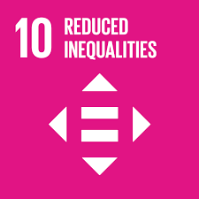

Introduction
The McMillan Shakespeare Group (‘MMS’, ‘we’, ‘the Group’) Accessibility and Inclusion Plan is an important first step in enhancing accessibility and inclusion for people living with disability and carers of persons with disability who engage with the MMS Group.
Through this Plan, we will build accessibility and inclusion into the core of how we do business and begin to systematically remove barriers experienced by people with disability in accessing our workplaces, products and services.
By taking a holistic and integrated approach to embedding accessibility into all aspects of our business, our goal is to create a culture of belonging, safety, dignity, and respect for people living with disability, while designing our products and services with inclusion as a key consideration.
This Plan also reflects our proactive approach to taking reasonable precautions and exercising due diligence to eliminate disability discrimination and promote the recognition of fundamental rights of people living with disability in accordance with the Disability Discrimination Act (1992) in Australia and equivalent legislation in countries where we operate. We also acknowledge the United Nations Convention on the Rights of People with Disabilities and recognise their families, service providers and their respective communities.
We recognise that enhancing accessibility is a journey of continuous improvement. Our first Plan sets out a number of pivotal initiatives to establish strong foundations to build upon into the future, including conducive governance and policy settings, defining our sphere of influence, as well as increasing disability awareness across our leadership and people.

Message from our Managing Director and CEO
I am delighted and honoured to present MMS Group’s first Accessibility and Inclusion Plan, which highlights our proactive and long-term commitment to improving accessibility and inclusion for people living with disability and carers of persons with disability.
With approximately one in six Australians living with a disability, we know that disability touches all aspects of our business. Across all of the Group’s brands, we interact with employees and customers with disability in Australia, NZ, and the UK, and we work closely with a network of clients and partners in the disability sector. Our Plan Group businesses in particular are part of the disability community, through the provision of plan management and support coordination services to the participants of the National Disability Insurance Scheme (NDIS).
This Plan supports and formalises MMS’s long-standing commitment to creating a diverse and inclusive workplace that fosters equal opportunities for all our people. We strongly believe that leveraging the unique perspectives and contributions that a diverse workforce brings is critical to our success as an organisation and the services we provide to our customers. That is why our initial focus under this Plan is to implement policies and initiatives that not only support, but encourage, a safe, aware, and disability-confident culture at MMS. By doing this in a meaningful and holistic way, we will be able to attract and retain employees living with disability and other accessibility needs and enhance their experience.
Through our Group’s operations and the strong network of clients and partners within the public, private, and charitable sectors, we recognise the unique contribution we can make in removing barriers faced by people living with disability and carers of persons with disability.
This Plan supports MMS’s vision and strategy to support the financial wellbeing and lifestyle goals of our customers. As part of this aspiration, we will explore opportunities to work with our clients, business partners, and other organisations to improve access to our products and services for people living with disability and create meaningful and sustainable community outcomes through our sphere of influence.
The Accessibility and Inclusion Plan has the full support of the MMS Board and the Group Executive Team. It will be governed by the Accessibility Working Group with accountability to the MMS Sustainability Committee to ensure we deliver on our commitments. We will be transparent about our progress with all our stakeholders.
The Accessibility and Inclusion Plan is an important moment for the Group; however, it is just the first step on a long and necessary journey. I look forward to seeing this program evolve and deliver many benefits, not just within MMS but to the wider community.
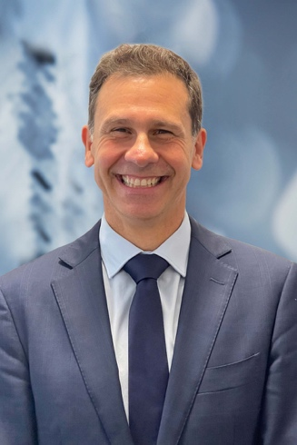
Rob De Luca
Managing Director and CEO
McMillan Shakespeare Group

Understanding disability

What is disability?
In Australia, the statutory definition of disability is provided by the Disability Discrimination Act 1992. We also consider the contemporary social definition of disability by the United Nations Convention on the Rights of Persons with Disabilities.
The Disability Discrimination Act defines disability as any impairment, abnormality, or loss of function of any part of the body or mind including, physical, intellectual, psychiatric, sensory, neurological, and learning disability, physical disfigurement, and the presence of disease-causing organisms in the body.
The United Nations Convention on the Rights of Persons with Disabilities describes people with disability as those who have long-term physical, mental, intellectual, or sensory impairments which, in interaction with various barriers may hinder their full and effective participation in society on an equal basis with others. This is called the ‘social model of disability’, which views disability as stemming from the way people interact with their environment and society. It places emphasis on the removal of physical, digital, attitude and communication barriers to provide equitable experiences for people with disability.
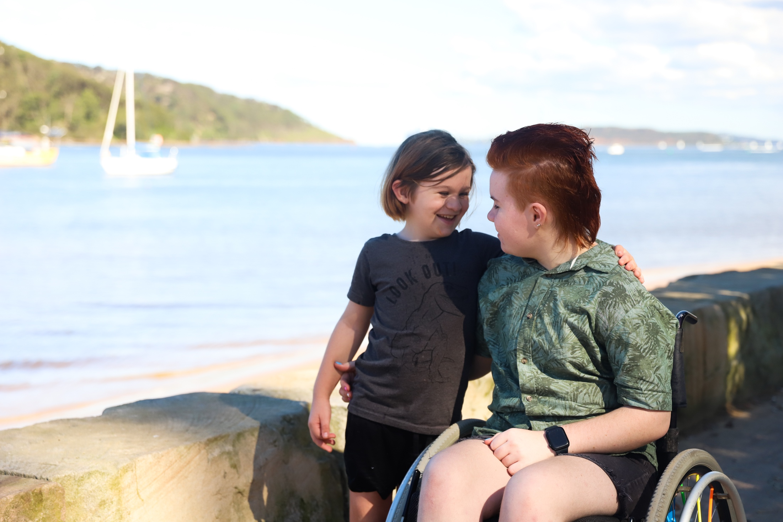

Disability in Australia
Disability is a normal part of the human experience, with 1 in 6 Australians living with some form of disability. Disability can be visible or non-visible, with a higher prevalence of non-visible disability in Australia. It can also be inherited or acquired (due to illness or injury) and can be temporary or permanent.
People with disability are as diverse as those without. They are parents, spouses, teachers, managers, employees, athletes, doctors, artists and more. Our perceptions of people with disability are socially and culturally conditioned. Negative attitudes and assumptions, often based on misunderstanding and ignorance, can shape the way we behave towards them. Progress is being made on this front, but there’s a long way to go, both in Australia and across the world.

Statistics
- 18% of Australians have a disability – that’s 4.4 million people
- Only 24% of adults with disability experience very good or excellent health
- 48% of working-age people with disability are employed, compared to 80% of people without
- By 2030, the National Disability Insurance Scheme (NDIS) is projected to provide approximately $60 billion in funding a year to over 850,000 Australians who have permanent and significant disability. For many people, it will be the first time they receive the disability support they need.
- 2.6 million Australians provide unpaid care, with 72% of primary carers being female
At MMS:
- 3% of MMS workforce identify as living with disability
- 49,218 hours of support coordination services provided to NDIS participants by Plan Partners during the last financial year
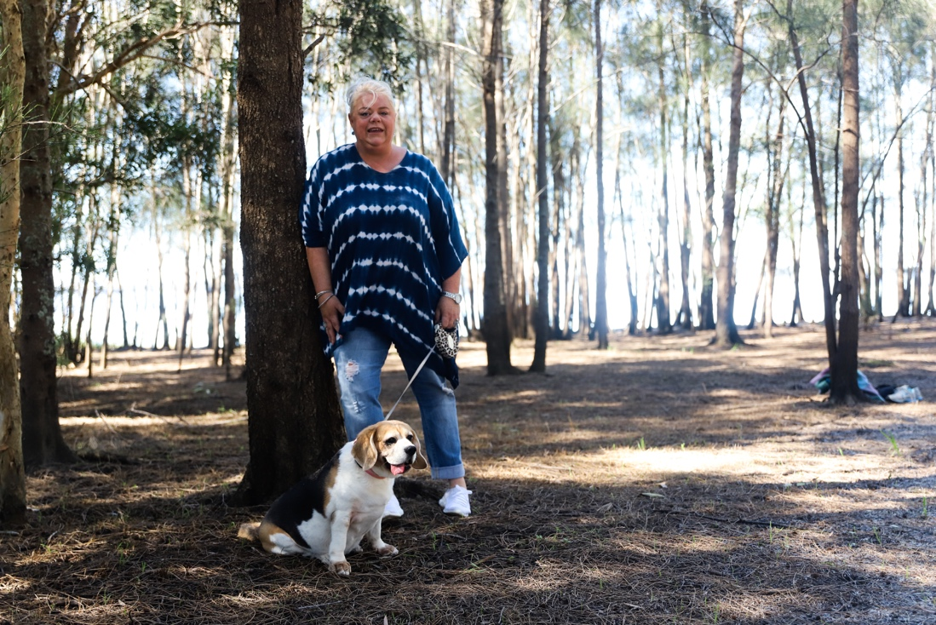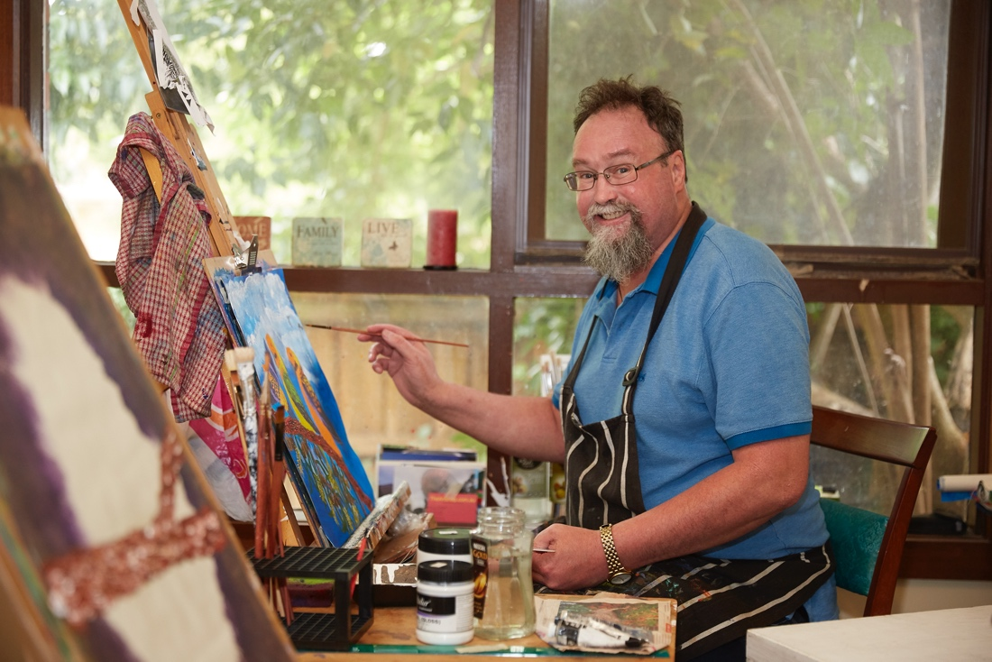

MMS Stories

A Lifestyle Lease for Ability Options
In collaboration between Maxxia, Interleasing and Plan Partners, we organised a Lifestyle Lease for Plan Partners’ provider Ability Options for two of their commuter buses that provide transport for customers with disability.
Part of a Lifestyle Lease requires our Remarketing department to view vehicles before we purchase them from the customer and then lease back to them. Ability Options needed a tight turnaround for their customers and their commuter buses were located a considerable 760 kms away. We were able to draw from resources within Maxxia to get the vehicles inspected and to create a leasing solution within the timeframes Ability Options were hoping for.
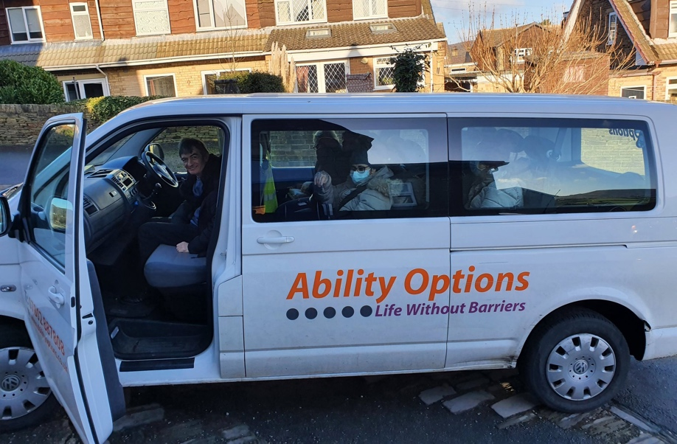

Interleasing partners with Kirinari
Interleasing client, Kirinari Community Services, offer disabled transport services in the Albury, Greater Hume, and Federation Councils. While Community Transport Organisation members’ vehicles have historically been funded by Transport for NSW, Kirinari’s transport services were impacted when the government agency declared that to continue to receive funding, vehicles can only be leased and not bought outright.
Interleasing stepped in to provide a leasing solution to approximately 70 companies under the Community Transport banner, which included Kirinari.
Kirinari were the first Community Transport member to sign with Interleasing, and a deal was secured for the delivery of nine new vehicles to help replenish their ageing fleet.
Mercedes Sprinters were identified as the best match for Kirinari’s purposes, due to the flexibility of the wheelchair fitment, rear bus design and the new and improved bus features. But there was a nine to ten-month wait due to lack of vehicle stock.
Through an associate at Mercedes Benz, Interleasing managed to secure nine Sprinters, and worked with wheelchair provider Norden to fit the vehicles to specification.
CEO of Kirinari Community Services, Diane Lynch, said, “It’s wonderful that we are partnering with Interleasing to upgrade our fleet ensuring the highest safety, accessibility, and comfort for our customers. In addition to Kirinari Community Transport, customers from The Buzz, Kirinari’s day program for people with disability, will be the first to benefit from the improved accessibility and safety features on show in the new vehicles”, she said.

Our business

MMS Group
The MMS Group is a trusted, market-leading provider of salary packaging, novated leasing, asset management, NDIS plan management and support coordination, and other related financial products and services.
Through our brands, we offer a breadth of services and expertise, designed to responsibly deliver superior long-term value to our customers.
The Group employs a highly committed team of over 1,300 people across Australia, New Zealand and the United Kingdom and manages programs for some of the largest public, private and charitable organisations.
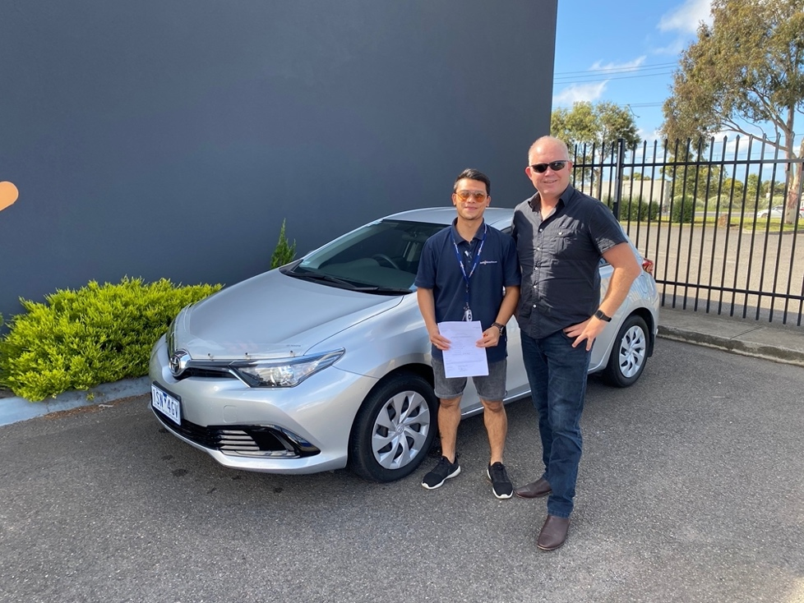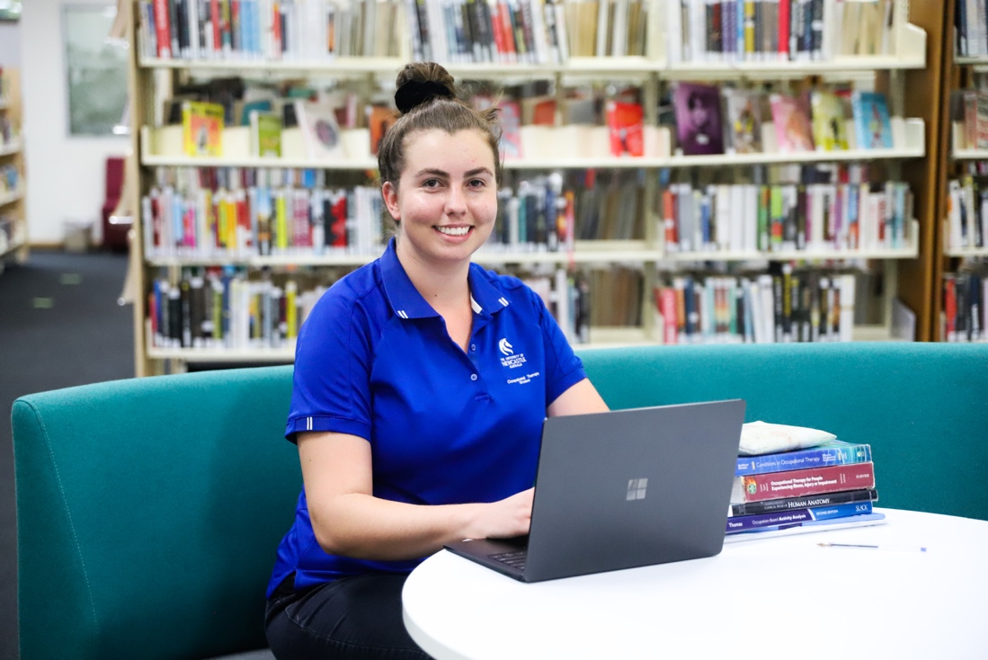

Our brands
- Maxxia
- RemServ
- Onboard Finance
- Interleasing
- Just Honk
- NFC Aggregation
- UFS Aggregation
- Plan Partners
- Plan Tracker

The Plan Group businesses
Plan Partners and Plan Tracker are leading providers for plan management, and in the case of Plan Partners, support coordination, to NDIS participants across Australia. Both businesses provide important tools, information, and guidance to simplify the NDIS and support participants to get the most out of their plans and funding and drive what’s possible.

Our purpose and vision
At MMS, our purpose is to make a difference in people’s lives, with a vision to be a trusted partner, supporting our customers’ financial wellbeing and lifestyle goals.
We put our customers and clients at the centre of everything we do and strive to meet their evolving needs by finding new and sustainable ways of creating value.
We are committed to helping people achieve their goals to live a better life – an aspiration that extends to our stakeholders, including our customers, our people, our business partners, and the communities we serve.
Our commitment to improving accessibility and inclusion is a core element of our Purpose and Vision, as we seek to remove the barriers that impact our customers’ and peoples’ ability to achieve their goals in life.
Our values are, better together, we put people first and work together to pursue better outcomes. This underpins our core belief that we are better together.

Sustainability at MMS
Creating shared value for all our stakeholders is core to the MMS approach to sustainability.
Our Group sustainability strategy aims to create positive social and environmental outcomes throughout our business and value chain, as we continually strive to improve our business practices and stakeholder relationships.
Customer wellbeing and social inclusion is a key pillar of our sustainability strategy with a focus on creating opportunities for vulnerable people in our communities. This Plan is our commitment to ensuring that people living with disability are provided with equal opportunity to thrive in our workplace, access our products and services and are a key stakeholder in our decision making.

Our commitment to diversity and inclusion
MMS strives to create and nurture an environment where all our people feel valued, respected, and comfortable to be their authentic selves, as we support them to succeed and grow.
We strongly believe that a diverse and inclusive workforce brings a wide range of skills, perspectives and ideas that puts us in a stronger position, through greater employee engagement and innovation, and our ability to understand our customers and meet their needs.
Through our biennial Employee Engagement survey conducted in 2021, we found that approximately 3% of our employees identify as living with disability. In comparison to the proportion of people with disability in Australia, the number of people in our organisation with disability, either unknown or undisclosed, is likely far greater. We also know that the average level of employee engagement across employees who identify as living with disability lags behind our Group average.
We recognise that we have more work to do in creating employment and development opportunities and a better experience for people living with disability at MMS, as well as building greater awareness, understanding and appreciation for disability across our leaders and people.
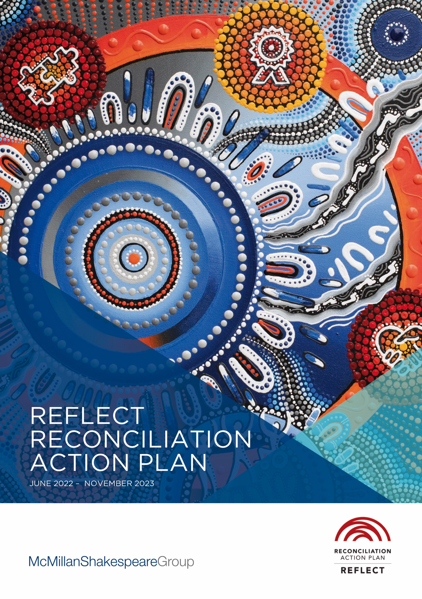

Our Reconciliation Action Plan
In 2022, MMS developed our first Reflect Reconciliation Action Plan (RAP), which aims to create meaningful opportunities for Aboriginal and Torres Strait Islander Peoples throughout our business. Our Accessibility and Inclusion Plan ill work in conjunction with our RAP to help address imbalances in social, economic and health outcomes experienced by Aboriginal and Torres Strait Islander Peoples living with disability. This will be particularly achieved through our Plan Group businesses, which work to empower people accessing the NDIS to achieve their life goals.

Our vision for accessibility and inclusion
MMS is committed to removing environmental and cultural barriers for people living with disability and carers of persons with disability, to help them achieve their goals in life. We will do this by fostering a diverse and inclusive workplace and enhancing the accessibility of our products and services, in order to promote equitable economic and social opportunities and inclusion for all.

MMS Stories

Sandra’s story
Sandra started her part-time position within Customer Service at MMS ten years ago. Being able to work part-time is essential for Sandra because her Carer’s Pension limits her to working 25 hours per week - including travel time.
“Being able to work part-time gives me the flexibility I need to care for my son, so I can take him to his medical and counselling appointments,” says Sandra.
While Sandra believes MMS has a great workplace culture and supportive management, she claims part-time positions are now far and few between.
“The jobs advertised every week are full-time,” Sandra says, “so if I wanted to get a promotion, or move sideways into client relations or another department, my options are limited.”
Sandra has embraced the flexible working conditions accelerated by the pandemic. Her preference would be to remain working from home permanently rather than go back to the office.
“Working from home has been wonderful because I am able to provide more support to my son,” she says. “For example, I can make sure he gets up at a reasonable time and eats healthy meals.”
To make workplaces more accessible for people with disability, Sandra believes every situation is different and we should be asking what individuals need to be able to do their job, rather than implement a one-size-fits-all solution.
“A lot of employers are put off because they have to implement this or that when it comes to making workplaces accessible,” says Sandra. “I believe a one-size-fits-all mentality is the wrong approach because each person is unique. We should be looking at how an individual can best do the job, and what, if any, support requirements that individual needs.”

Sylvia’s story
Customer Admin Officer, Sylvia Grbin, is passionate about helping people realise the full extent of what’s possible with their NDIS funding.
An NDIS participant herself, Sylvia wanted to build her confidence and become more involved in the community but wasn’t sure where to start or what was possible. It was only after speaking with a colleague that she learned just how much more she could do with her current NDIS plan.
“After that discussion, it was like a whole new world had opened up. I was able to join cooking and yoga classes where I’ve developed new skills and made some great friends. Importantly, I’ve also gained a new appreciation of the creative things you can do with your NDIS funds if you have the right guidance.”
Sylvia is now pleased she can share her knowledge with customers, so they can follow in her footsteps and realise the full potential of their NDIS plan.

Our Accessibility and Inclusion Plan

Our journey to date
As a Group, our understanding of the challenges faced by people living with disability has been deepened in recent years because of our strong connections with the NDIS in Australia and the wider disability community through our plan management and support coordination services.
This view has led to the recognition that through the individual and business connections across our Group as a whole, we can influence positive equality and inclusivity outcomes for people living with disability, and those who are carers.
We highlight below some of the initiatives we have implemented to celebrate and better support people living with disability:
- Becoming members of the Australian Network on Disability (AND) in 2021.
- Celebrating International Day of People with Disability 2021 (IDPwD) across MMS Group to build internal awareness of disability amongst employees. We invited appearance activist and award-winning writer, Carly Findlay, to speak with us on disability and appearance diversity, and about her own experiences living with disability.
- Developing a new Plan Partners website, launched in June 2021, with a focus on accessibility and including an extensive Knowledge Centre, one of the richest free resources for NDIS information, tips, and updates. In addition, the new website was built with Web Content Accessibility Guidelines 2.1 at the forefront with a goal to eventually achieving a conformance rating of AA.
- Celebrating stories of customers with disability across our websites, social channels, and publications to increase awareness and understanding of both their challenges and achievements.
- Partnering with a Disability Employment Service provider to identify candidates for placement within Plan Partners, with the aim of continuing to identify other relevant partnerships and expand to the Group.
- Ongoing support of MMS Group clients working in the disability sector, including through corporate donations and fundraising initiatives.
This Plan will support us to further accelerate our efforts so we can lead the way in best practice policies and initiatives that create positive outcomes for our employees and customers with disability across all parts of our business.

Developing the Plan
Whilst our vision under this Plan has very much been a part of how we operate for many years, as a trusted partner of choice, MMS has recognised the need to have a well-coordinated and concerted approach to improving the accessibility and inclusion of our workplace, products, and services for people with disability and carers of persons with disability.
In creating this Plan, we used the Australian Network on Disability’s Access and Inclusion Index tool to benchmark our current practices, understand gaps in how we support employees and customers living with disability and identify opportunities for improvement.
To lead the development and implementation of key deliverables set out in this Plan, we have convened an Accessibility Working Group. The Working Group is collectively responsible for driving education and cultural change, and for developing stronger links with key stakeholders to create meaningful outcomes across the Group.
The Working Group is led by the Managing Director, Plan and Support Services, Sean Dempsey, who serves as the Senior Accessibility Champion for the Group, and includes our Chief Human Resources Officer, senior leaders representing brands across the Group, and employees who are carers of people with a disability.

Consultation with our partners
In developing this Plan, we sought input from a wide range of stakeholders to ensure our Plan’s appropriateness and relevancy to assist our employees and customers in accessing our workplaces, products, and services. Stakeholders we consulted included:
- People with lived experience with disability, including carers,
- Australian Network on Disability, and
- MMS Group clients and partners working within the disability sector.
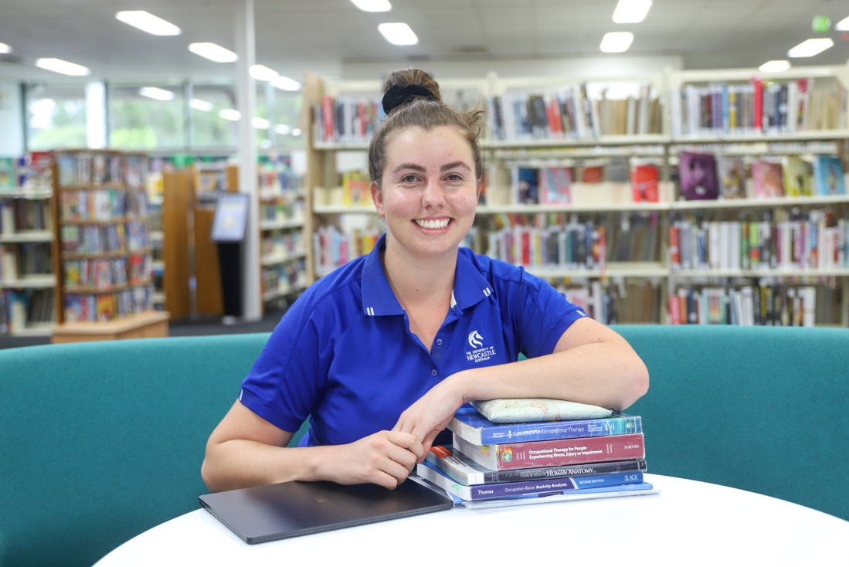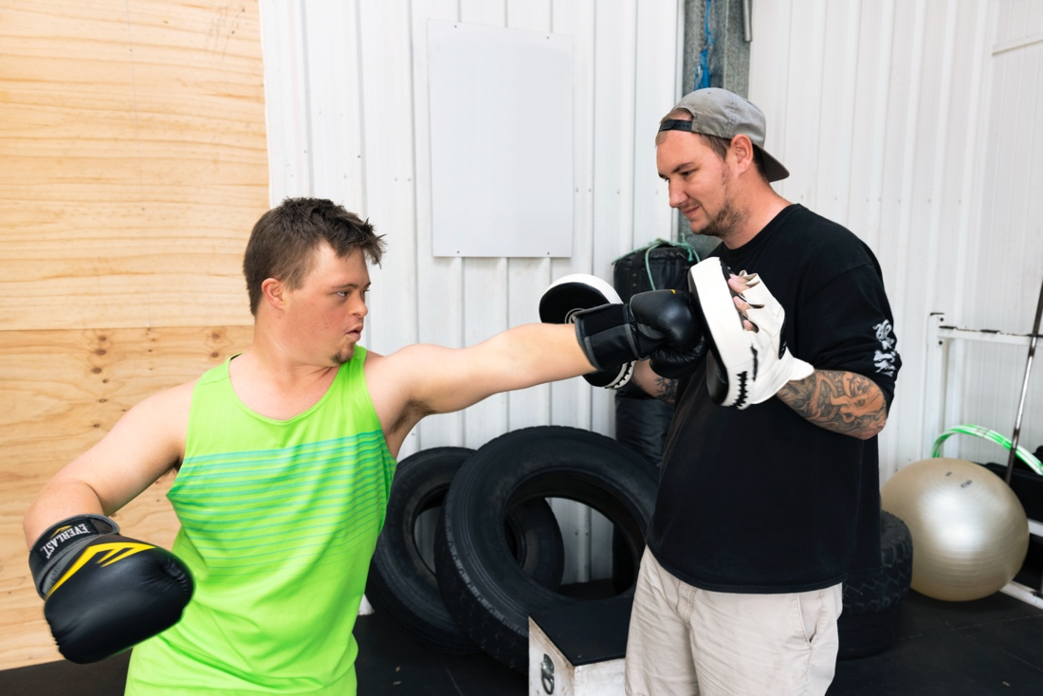

MMS Stories 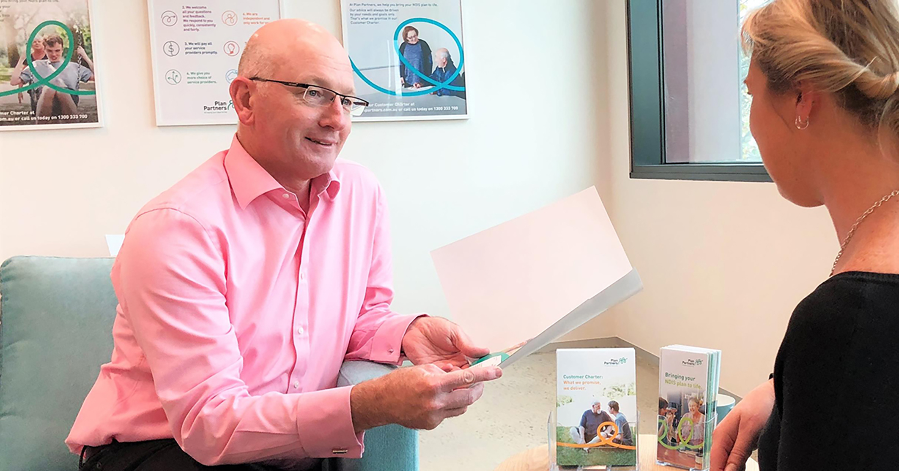

Meet our Accessibility Champion, Sean Dempsey, Managing Director – Plan and Support Services
I’m extremely excited to be the Accessibility Champion for MMS and to be a part of making our workplaces, communications, and offerings more accessible.
As Accessibility Champion, I can personify the Accessibility Working Groups’ views and make our Accessibility and Inclusion Plan a living organic commitment to improving access and inclusion over time. Rather than just a static policy, we have a face and a name to our efforts to promote what we’re doing and to move things forward.
My role is about having conversations and raising dialogue. I’d like to invite people to let me present about what accessibility means and to be a part of discussions, so that accessibility is entrenched in our processes, technologies, and products as they are being developed.
Success will range from small steps to big achievements, such as reshaping our workplaces and creating a disability aware and confident culture, to providing accessible versions of publicly facing documents and making our websites WCAG 2.1 compliant.
Gradually, we can engrain accessibility into our culture and people, so that it is an integral part of everything we do.

Outcomes
Our Accessibility and Inclusion Plan is an evolving commitment to improving access and inclusion across our organisation over time. The key outcomes we seek to achieve through our Plan are to:
- Provide more equitable and dignified access to our products, services and workplaces for people and customers with disability or access challenges and carers of persons with disability.
- Provide better experiences for customers, employees, and community members with disability in their interactions with MMS.
- Create a disability confident organisation and an inclusive culture by enhancing our people’s level of disability awareness.
- Create improved employment opportunities and outcomes for people living with disability and carers of persons with disability (including attracting new and retaining current employees living with a disability and carers, increasing broader employee engagement, culture of inclusion, and sense of pride and purpose in working at MMS).
- Extend our impact through collaboration with our stakeholders – our clients, suppliers, partners, and community organisations – to support and encourage opportunities for people living with disability.
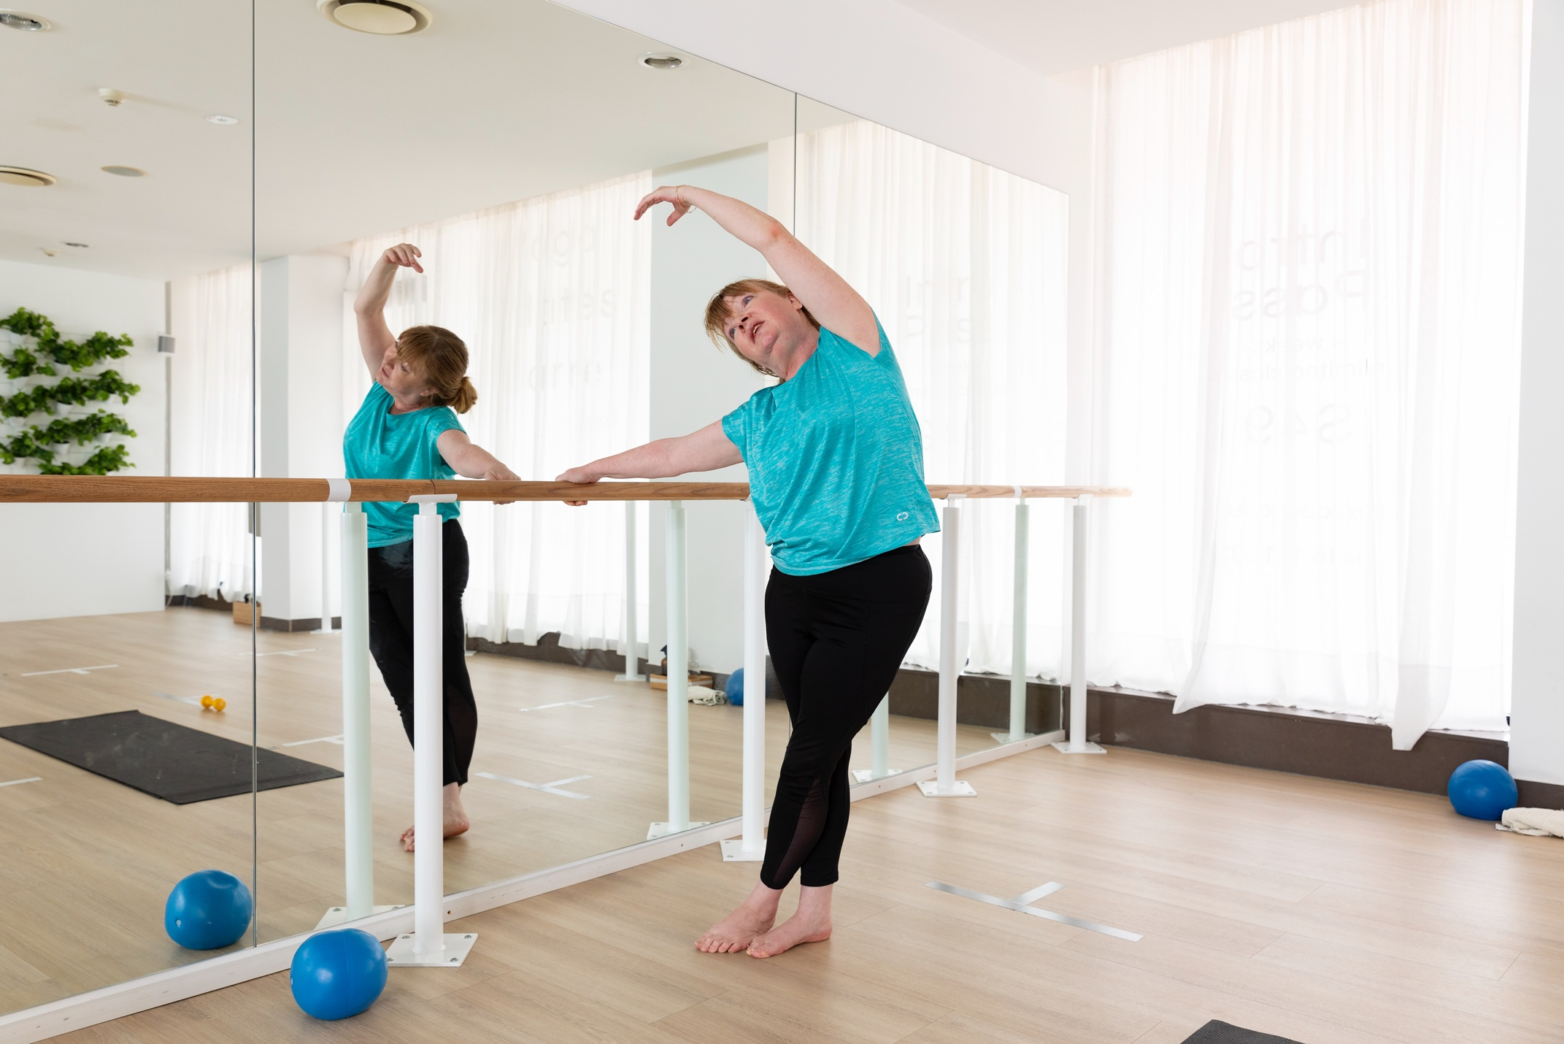

Our commitments

1. Governance
Our Aim: MMS Group commits to holding ourselves accountable for improving access and inclusion.
Category | Action | When | Responsibility
Governance | 1.1 Establish and implement Terms of Reference for the AIP Working Group | Sep 2022 | Managing Director, Plan and Support Services
Governance | 1.2 Appoint and raise the profile of the MMS Disability Champion both internally and externally. | June 2023 | Managing Director, Plan and Support Services
Governance | 1.3 Participate in Australian Network on Disability’s Access and Inclusion Index to independently measure the progress we have achieved in enhancing accessibility for people living with disability. | Mar 2024 | Managing Director, Plan and Support Services
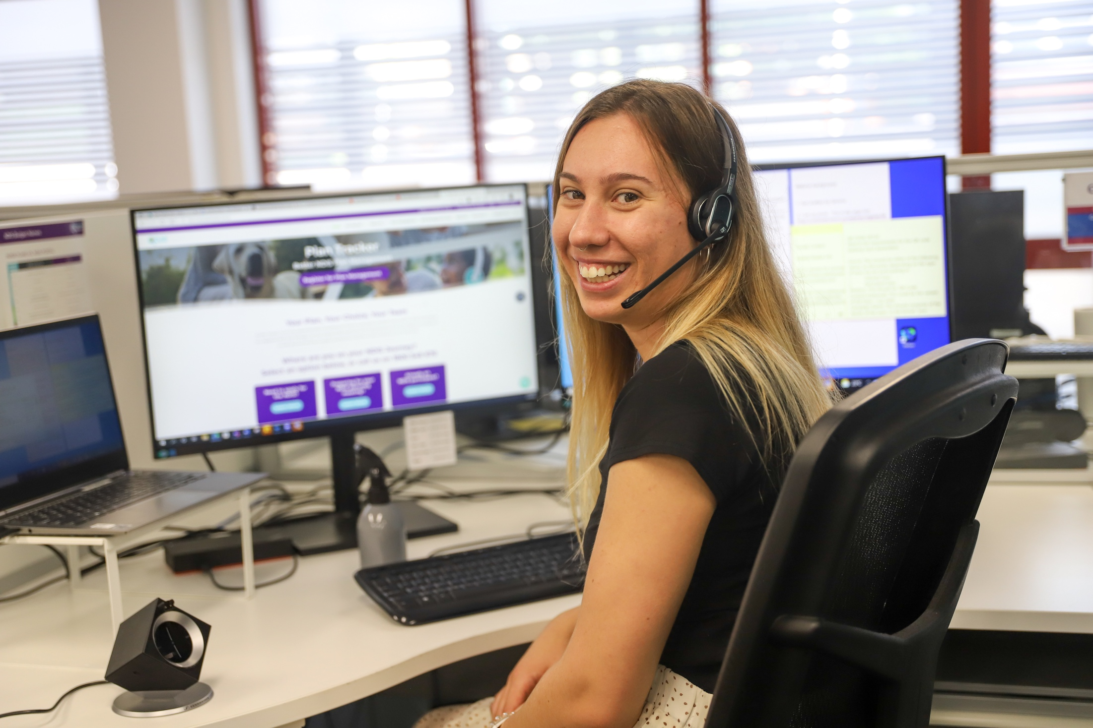

2. Our People
Our Aim: MMS Group is committed to improving equal employment and career development opportunities for people living with disability, including wider cultural focus and education to employees and leaders across the organisation.
Category | Action | When | Responsibility
Our premises | 2.1 Audit and review existing premises with the landlords for accessibility and develop a report for remedial action. | Apr 2024 | Chief Human Resources Officer
Our premises | 2.2 Document requirements for new property leases, rentals, or purchases to meet accessibility requirements | Jun 2023 | Chief Human Resources Officer
Our premises | 2.3 Provide all employees the opportunity to request a Personal Emergency and Evacuation Plan (PEEP) at any point throughout the employment lifecycle. | Jun 2023,  Jun 2024 | Chief Human Resources Officer
Workplace adjustments | 2.4 Develop and formalise a Workplace Adjustment Policy and Procedure that is inclusive and considers the reasonable needs of all current and future employees of the Group and career development opportunities for our people. | Jun 2023 | Chief Human Resources Officer
Workplace adjustments | 2.5 Incorporate into existing policies and mechanisms, avenues for employees to provide confidential feedback in relation to accessibility and inclusion matters. | Sep 2022 | Chief Human Resources Officer
Talent attraction | 2.6 Incorporate opportunities for employment of people living with or caring for people with disability into the MMS employee value proposition. | Dec 2022 | Chief Human Resources Officer
Talent attraction | 2.7 Provide training and resources to employees responsible for recruitment, selection, and other relevant human resource services to assist them in providing support for candidates and employees with disability. | Mar 2023 | Chief Human Resources Officer
Talent attraction | 2.8 Review and enhance our recruitment and selection process to ensure we articulate our commitment to supporting people with disability. | Dec 2023 | Chief Human Resources Officer
Talent attraction | 2.9 Engage and establish relationships with disability employment and job readiness service providers to recruit and provide continuous job support for candidates with disability in our workforce. | Dec 2022 | Chief Human Resources Officer
Career development | 2.10 Develop competence and confidence of our people leaders to better support people with disability with career development. | Mar 2023 | Chief Human Resources Officer
Career development | 2.11 Audit our learning and development activities to identify where MMS Group can implement and provide accessible and inclusive career development opportunities. | Jun 2023 | Chief Human Resources Officer
Career development | 2.12 Offer and provide reasonable adjustments and alternative formats to ensure learning and development opportunities are accessible to employees with disability. | Mar 2024 | Chief Human Resources Officer
Internal communication | 2.13 Promote our accessibility plan both internally and externally to partners and the wider community. | Sep 2022 | Chief Customer Officer
Internal communication | 2.14 Build employee awareness and disability confidence through recognition of key dates in the calendar year such as International Day of People with Disability. | Dec 2022  Dec 2023 | Chief Customer Officer
Internal communication | 2.15 Increase the representation of people with disability in our communication and marketing materials. | Ongoing | Chief Customer Officer
Internal communication | 2.16 Establish and promote an Accessibility Hub within the intranet to share information on accessibility support and services. | Sep 2022 | Chief Customer Officer

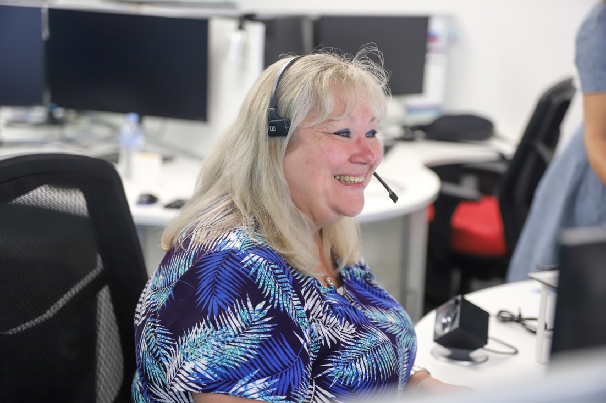

3. Our Customers
Our Aim: MMS Group is committed to improving customer experience through accessible and inclusive product and service design and with the guidance and input of the people we serve.
Category | Action | When | Responsibility
Products, services, and innovation | 3.1 Develop and implement accessibility guidelines for all digital, print and media channels. | Jun 2023 | Chief Customer Officer
Products, services, and innovation | 3.2 Provide training and resources to support our customer service employees to actively welcome customers with disability and confidently accommodate reasonable adjustment requests. | Jun 2023 | Group Executive – Customer Strategy & Operations
Products, services, and innovation | 3.3 Provide National Relay Service and Translating and Interpreting Service training to our employees. | Mar 2023 | Group Executive – Customer Strategy & Operations
Products, services, and innovation | 3.4 Develop a framework that embeds accessibility in the development lifecycle of products. | Aug 2022 | Chief Customer Officer
Products, services, and innovation | 3.5 Implement a Customer Engagement survey for customers with disability on delivery of MMS's products and services. | Dec 2022 | Chief Customer Officer
Products, services, and innovation | 3.6 Review our “Voice of the Customer” feedback for accessibility issues and report to the MMS Accessibility Working Group biannually | Dec 2022,  Jun 2023,  Dec 2023,  Jun 2024, | Chief Customer Officer
Products, services, and innovation | 3.7 Undertake a review of all digital assets to assess accessibility status for WCAG 2.1 AA compliance | Jun 2024 | Chief Customer Officer
Products, services, and innovation | 3.8 Create a Groupwide customer panel to consult on the accessibility of products and services. | Apr 2023 | Managing Director, Plan and Support Services
Products, services, and innovation | 3.9 Engage with our clients about how we support their employees with disability by incorporating accessibility considerations into regular client interactions | Feb 2023 | Group Executive – Client Strategy & Engagement
Products, services, and innovation | 3.10 Create an Accessible Events checklist to be used for all MMS-led events. | Dec 2022 | Chief Human Resources Officer

4. Our Partners
Our Aim: MMS Group is committed to working with stakeholders within our sphere of influence to promote greater access and inclusion for people living with disability in our broader communities.
Category | Action | When | Responsibility
Suppliers and partners | 4.1 Review procurement documentation to express our commitment to access and inclusion of people with disability and working with organisations with similar goals. | Oct 2022 | Managing Director – Asset Management Services
Suppliers and partners | 4.2 Incorporate access and inclusion into the vendor selection process to support suppliers who employ or support people with disability. | Mar 2023 | Managing Director – Asset Management Services
Suppliers and partners | 4.3 Identify and approach like-minded organisations, including clients, that we could collaborate with on our disability confidence journey. | Mar 2023 | Group Executive – Client Strategy & Engagement
Suppliers and partners | 4.4 Investigate support for disability-focused community organisations or initiatives, as part of MMS community investment strategy | Dec 2022 | Head of Corporate Affairs

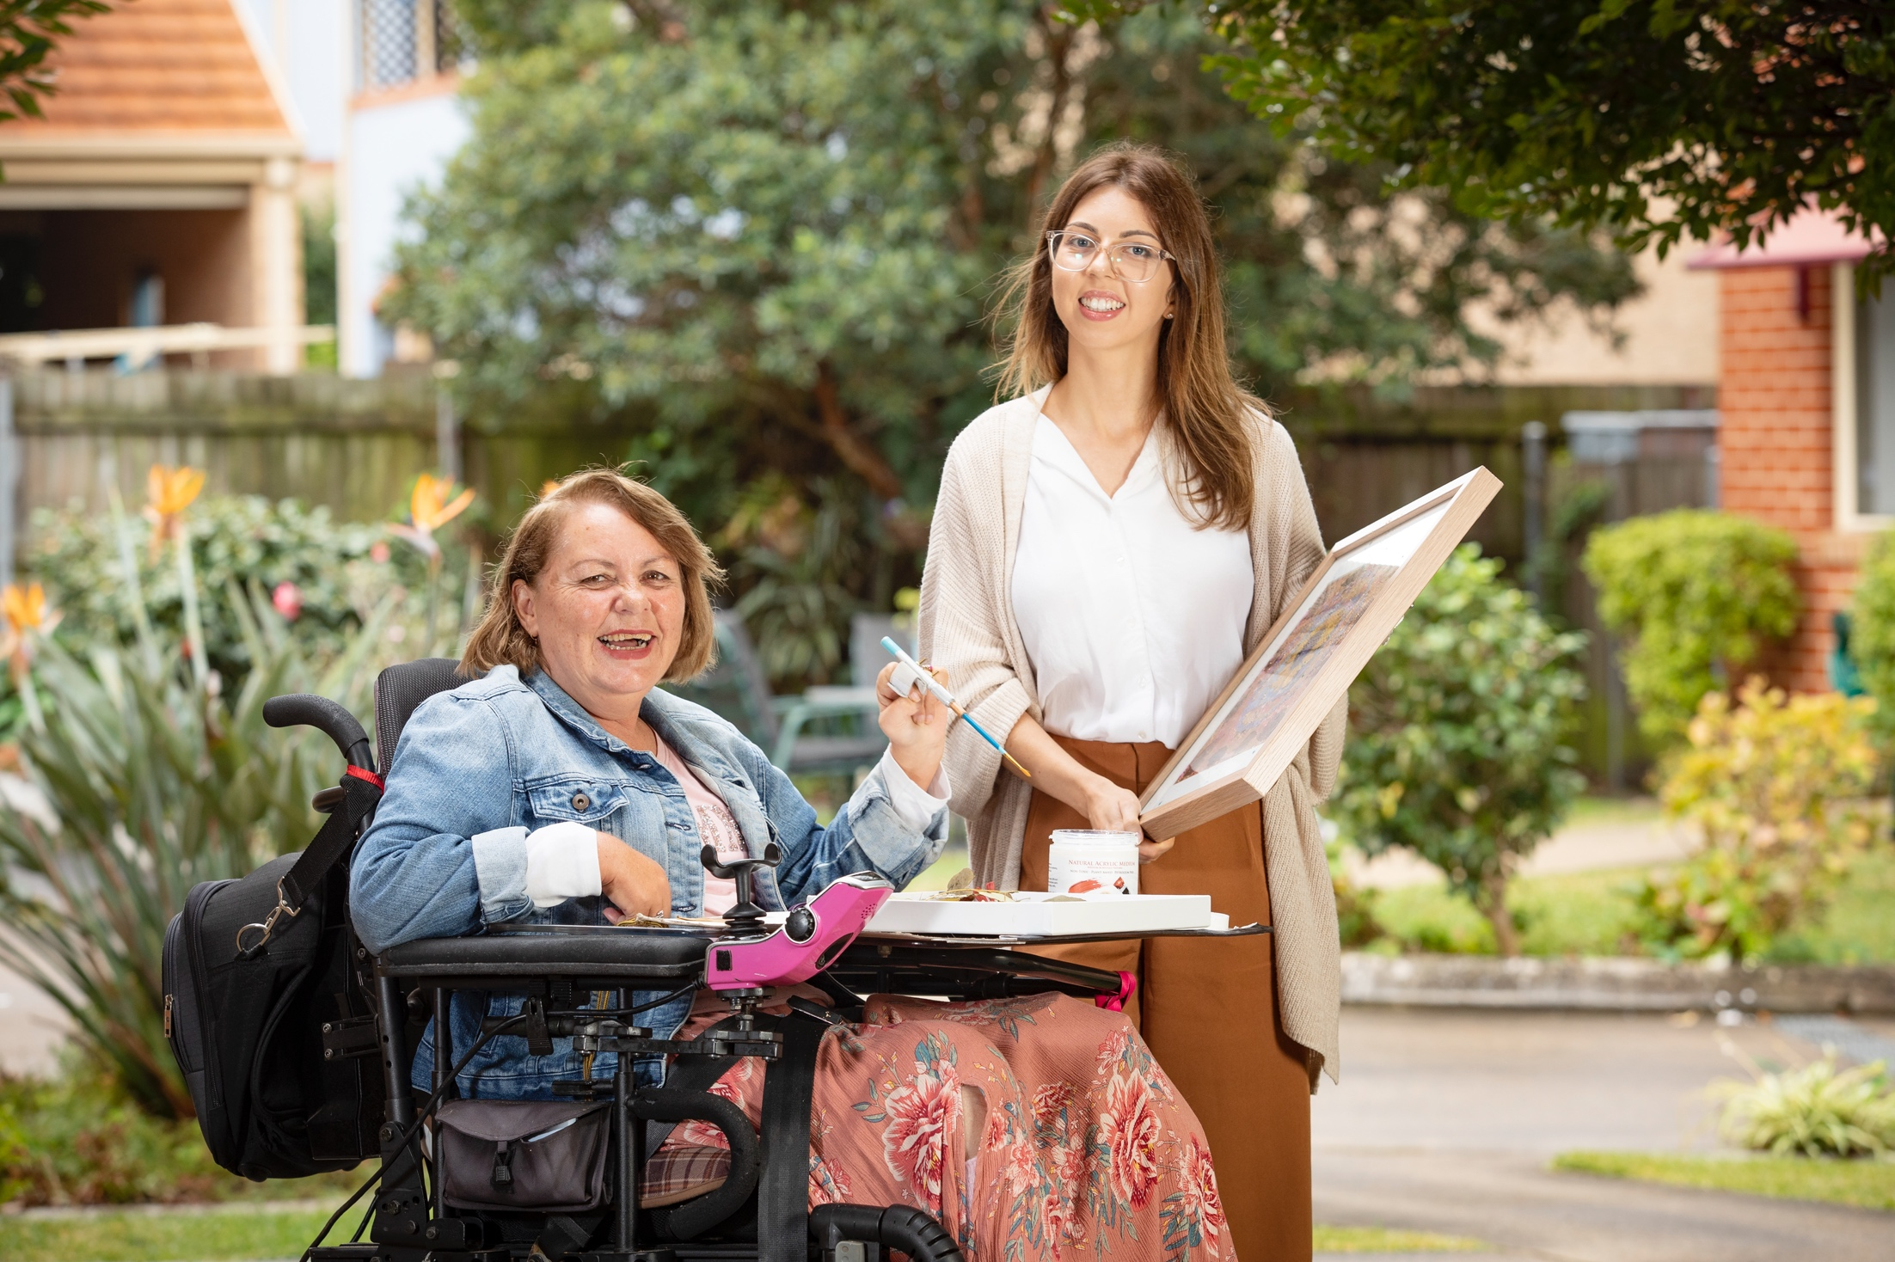

Contact us

Plan Tracker
PO Box 92
Gosford NSW 2250
Telephone: 1800 549 670

People with disability in Australia web report. AIHW, October 2020
People with disability in Australia web report. AIHW, October 2020
People with disability in Australia web report. AIHW, October 2020
Quarterly Report to Disability Ministers. NDIS, September 2021
Disability, Ageing and Carers, Australia. ABS, October 2019
Employees refer to all workers in an employment relationship with MMS, including fixed-term contract workers.

